HOTEL RESERVATION SYSTEM



**JANAKI**

UNDER GUIDANCE OF

JENNY JAFFRIN SIR

(Besant Technology BTM Layout)



HOTEL RESERVATION SYSTEM

## PROJECT TITLE

2

# WHAT IS SQL ? WHY IT IS USED?



SQL Stands for Structured query language.

It is used to communicate with database.

The Main feature of sql is it lets us access and manipulate database.

It is open source software

SQL runs on multiple platforms

And it is object oriented language

3

Query??

A query in SQL is a request for database or information from a Database table or

Combination Of

tables



**What is query??**

4



ABOUT HOTEL RESERVATION SYSTEM

It is an excellent application that significantly enhances the hotel booking experience for both customers and hotel staff

The entire reservation process and database storing , making it easier and convenient and effectient.

5

MORE ABOUT HOTEL RESERVATION SYSTEM

it is user friendly interface Efficient room management Secure payment processing

Flexibility for hotel data

maintainance

6

# SQL IN HOTEL RESERVATION SYSTEM



* Regular backup
* Secure connections
* User authentication and authorization
* Secure data storage

HANDLING SQL IN HOTEL RESERVATION SYSTEM

### Hotel reservation system is a database management system designed to handle hotel-related operations efficiently it uses SQL to manage database and perform various operations such as hotel and room management , customer registration , reservation handling payment processing and reporting



8

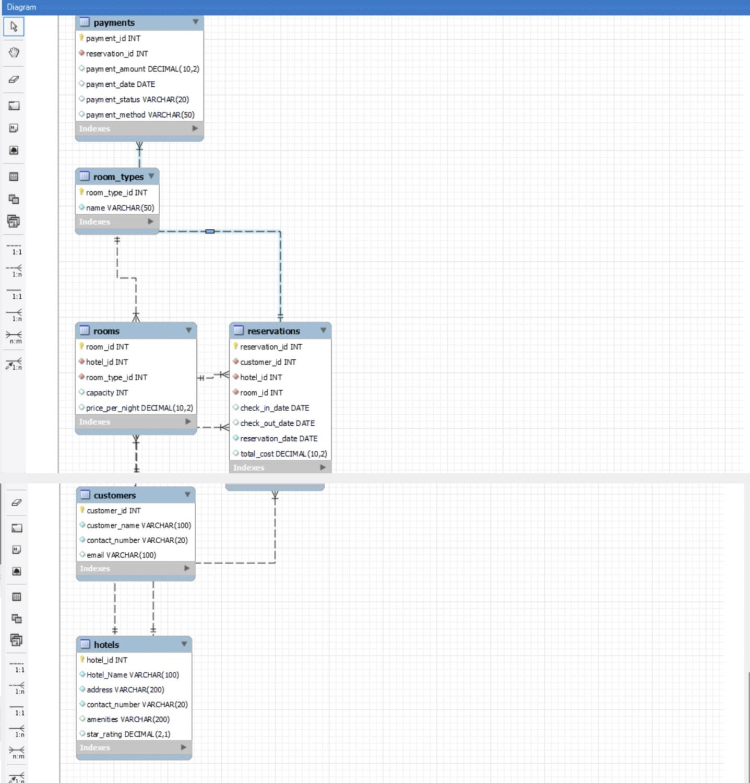

*ER - Diagram*

ER diagram is defined

9

as ENTITY RELATIONSHIP

DIAGRAM

* ER DIAGRAM REPRESENTS RELATIONSHIP AMONG ENTITIES IN A DATABASE
* IT PLAYS AN IMPORTANT ROLE IN DESIGNING THE DATABASE AND HELPS DATABASE ADMINISTRATORS

ER DIAGRAM FOR HOTEL RESERVATION SYSTEM

TABLES IN HOTEL RESERVATION SYSTEM



Hotels details

Room types

details

Rooms availability details

Customers

Reservations

Payments

10

1. 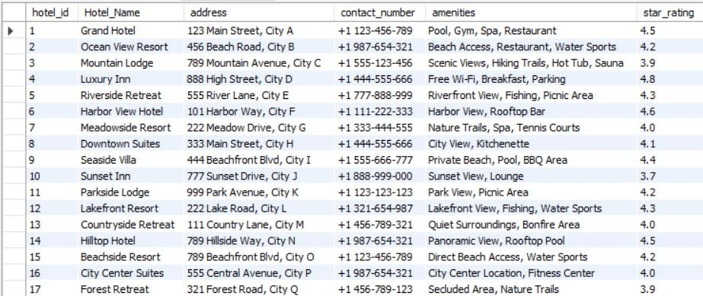HOTEL DETAILS

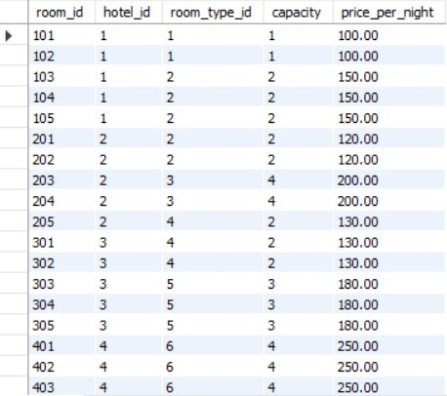

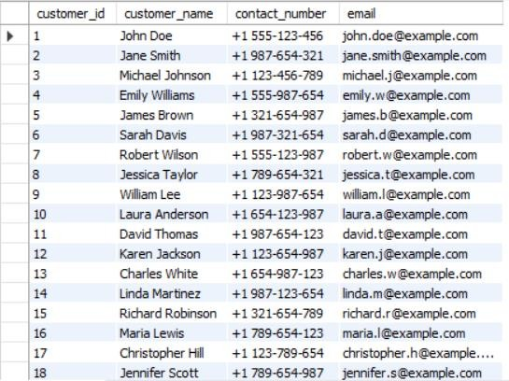3. CUSTOMER DETAILS

11

1. ROOM TYPES DETAILS

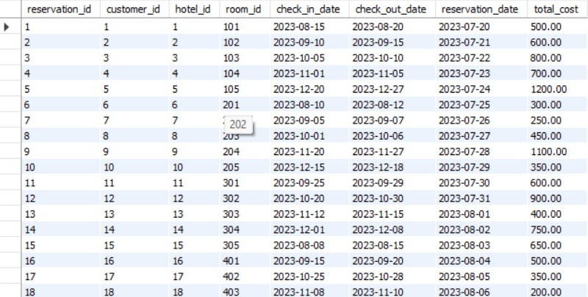4.RESERVATIONS

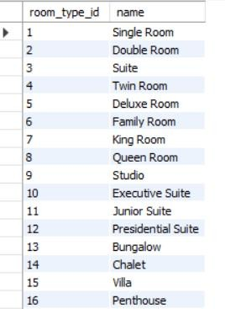

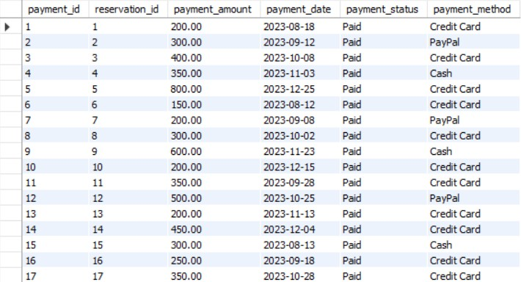6.PAYMENTS

5.ROOMS

12

## QUERIES FOR THE HOTEL RESERVATION SYSTEM

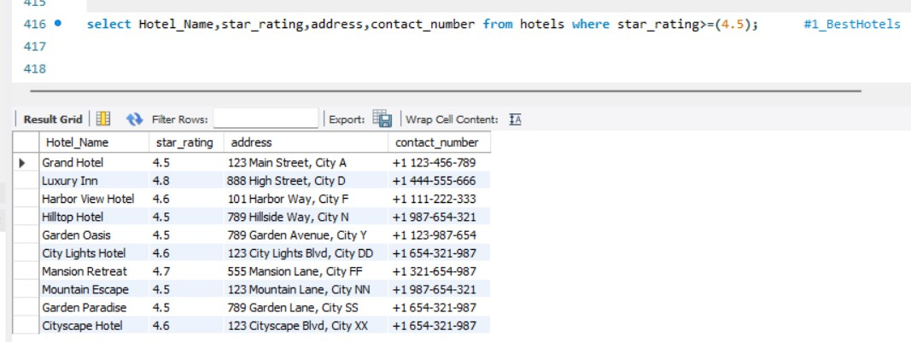

WRITE A QUERY FOR TO REPRESENT THE HOTELS WITH RATING MORE THAN 4.5?

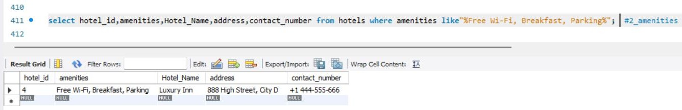

WRITE A QUERY TO LISTOUT HOTELS WITH FREE WIFI AND FREE PARKING FACILITIES?

WRITE A QUERY TO DISPLAY THE COUNT OF TYPES OF ROOMS ?

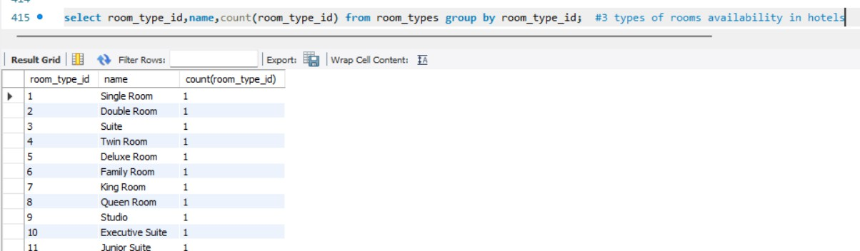

WRITE A QUERY TO DISPLAY CHECKIN AND CHECK-OUT DATES AND PAYMENT METHOD ?

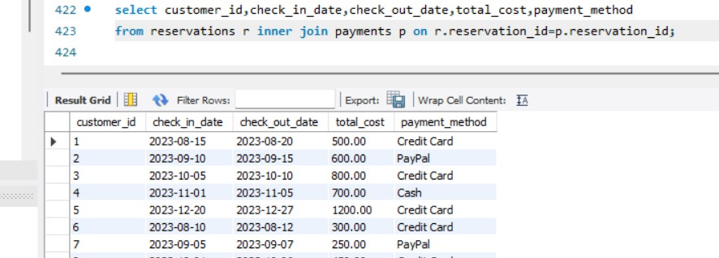

WRITE A QUERY TO COUNT OF PAYMENT OF CASH?

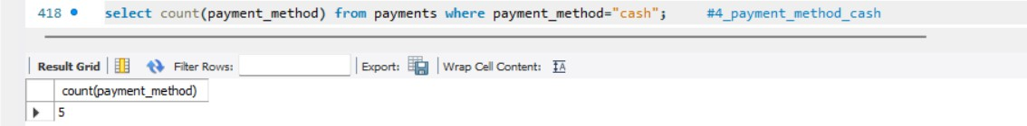

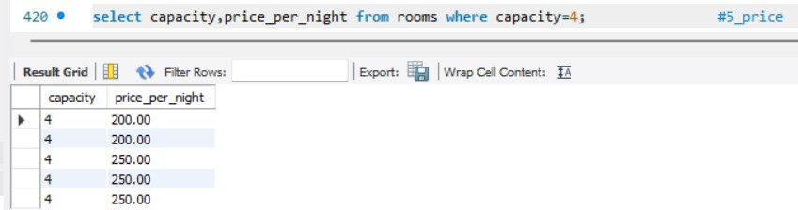WRITE A QUERY TO DISPLAY THE ROOMS WITH CAPACITY FOUR MEMBERS?

15

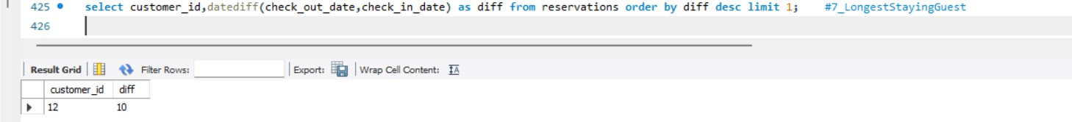

WRITE A QUERY TO DISPLAY THE TOP PERSON ID WHO STAYED MANY DAYS IN THE HOTEL?

WRITE A QUERY TO DISPLAY THE COUNT OF CAPACITY TWO MEM AND SUM OF THE CHARGE AS TOTAL CHARGE?

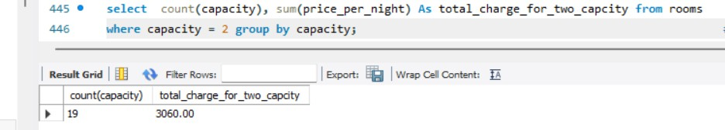

WRITE A QUERY TO DISPLAY THE CUSTOMER NAME WHO CHECKED IN IN THE MONTH OF AUGUST?

16

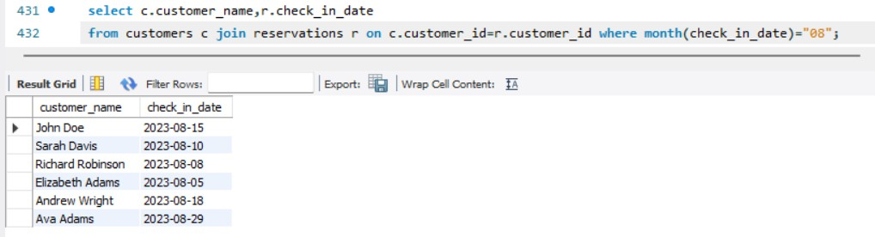

WRITE A EXAMPLE QUERY FOR STORED PROCEDURE?

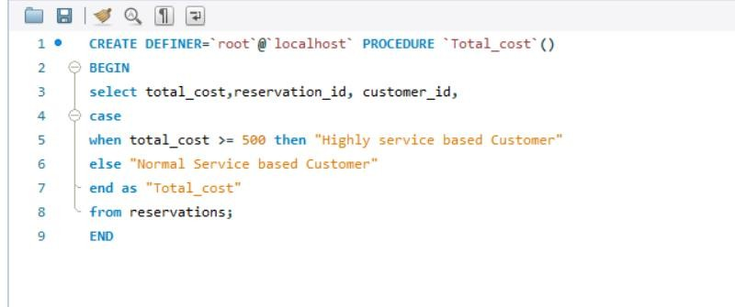

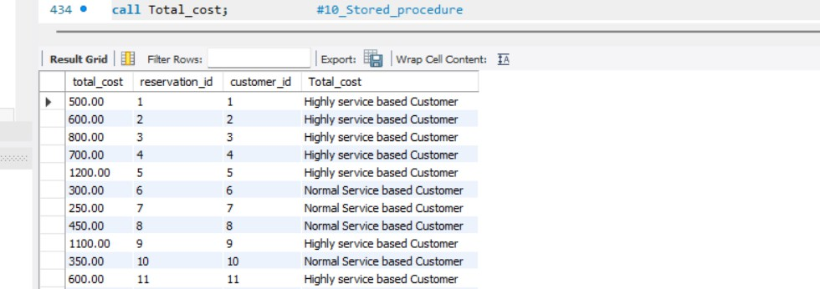

17

18

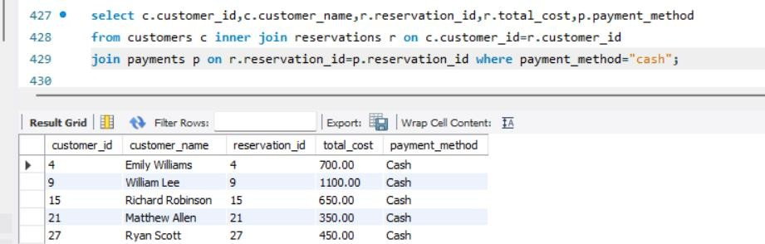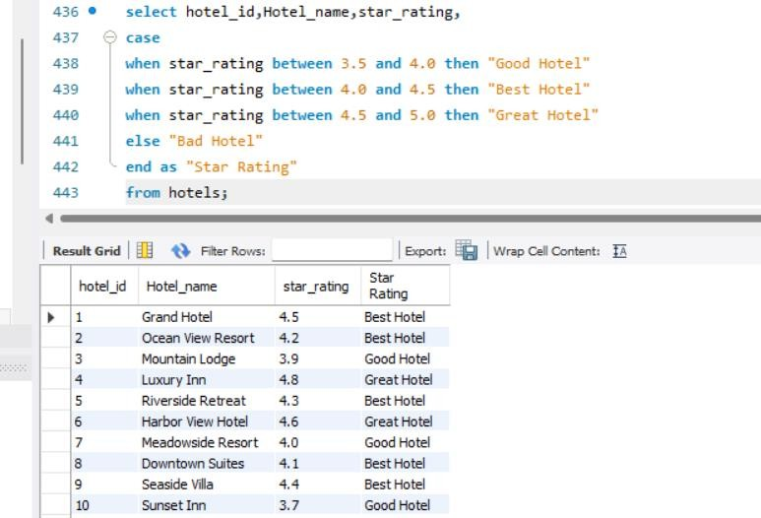WRITE A EXAMPLE QUERY FOR EL IF STATEMENT?

WRITE A QUERY TO DISPLAY TOTAL COST AND PAYMENT METHOD WHERE PAYMENT METHOD IS CASH?



19